


Echoes
Compass Informatics Statement of work
AWS Deployment Pipeline

Commercial and in confidence
Version 1.0 June 1, 2023

ECHOES

VERSION: 1.0.0 | REVISION DATE: [Date]

Approval of the Deployment Pipeline indicates an understanding of the purpose and content described in this deliverable. By signing this deliverable, each individual agrees with the content contained in this deliverable.

Approver Name | Title | Signature | Date

Echoes Technical Architecture Page 1 of 16

Document Scope
This document describes the process to deploy the ECHOES platform from Azure to AWS
The goal of this document is to explain how to deploy the solution from DevOps to AWS if work with GIT will need to adapt the steps and scripts.

Overall, of Echoes continuous integration to AWS

Continuous integration (CI) is the practice of automating the integration of code changes from multiple contributors into a single software project. It's a primary DevOps best practice, allowing developers to frequently merge code changes into a central repository where builds and tests then run.

Below is our current pipeline.

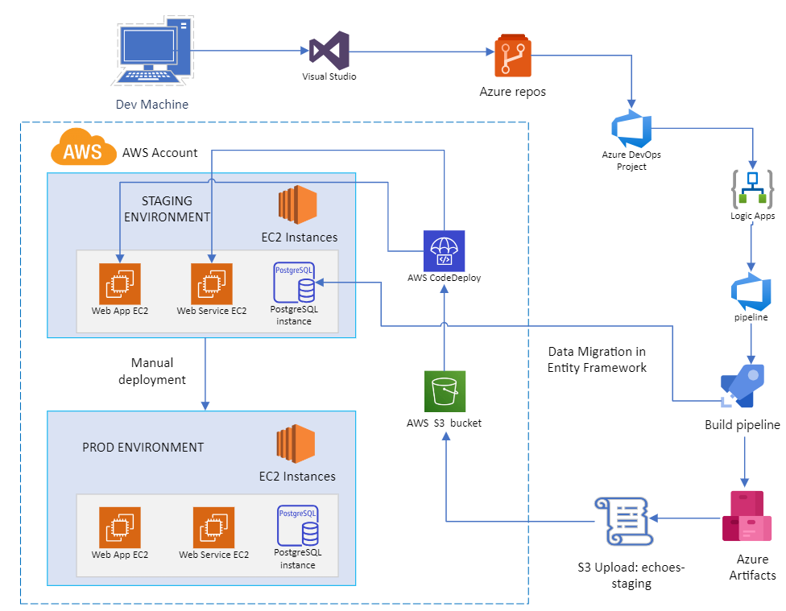

To create the deployment pipeline on DEVOPS, follow the steps below by adding the tasks.

1- Node.js tool installer (Use Node 16.13.x)

Finds or downloads and caches the specified version spec of Node.js and adds it to the PATH

YAML

steps:

- task: NodeTool@0

displayName: 'Use Node 16.13.x'

inputs:

versionSpec: 16.13.x

2- Use .NET Core Version 2
Acquires a specific version of the .NET Core SDK from the internet or the local cache and adds it to the PATH. Use this task to change the version of .NET Core used in subsequent tasks. Additionally provides proxy support.

What's new in version 2.*
Support for installing multiple versions side by side.
Support for patterns in version to fetch latest in minor/major version.
Restrict Multi-level lookup
Installs NuGet and provides proxy support.
Installs sdk versions from `global.json` file(s)

Path To Install .Net Core = $(Agent.ToolsDirectory)/dotnet

YAML

steps:

- task: UseDotNet@2

displayName: 'Use .NET Core sdk 3.x'

inputs:

version: 3.x

3- .NET Core (dotnet restore)
Build, test, package, or publish a dotnet application, or run a custom dotnet command

Path to project(s) = aspnet-core/src/Echoes.Web.Host/Echoes.Web.Host.csproj

YAML

steps:

- task: geeklearningio.gl-vsts-tasks-yarn.yarn-task.Yarn@3

displayName: 'Run yarn install'

inputs:

projectDirectory: '$/Echoes/EchoesAngular/angular'

arguments: install

4- Yarn Tool Installer
Installs a version of Yarn

YAML

steps:

- task: geeklearningio.gl-vsts-tasks-yarn.yarn-installer-task.YarnInstaller@3

displayName: 'Use Yarn 1.x'

5- Yarn task (Preview)
Executes Yarn

YAML

steps:

- task: geeklearningio.gl-vsts-tasks-yarn.yarn-task.Yarn@3

displayName: 'Run yarn install'

inputs:

projectDirectory: '$/Echoes/EchoesAngular/angular'

arguments: install

6- .NET Core
Build, test, package, or publish a dotnet application, or run a custom dotnet command

YAML

steps:

- task: DotNetCoreCLI@2

displayName: 'Publish .Net application'

inputs:

command: publish

publishWebProjects: false

projects: 'aspnet-core/src/Echoes.Web.Host/Echoes.Web.Host.csproj'

arguments: '--configuration Release --output $(Build.ArtifactStagingDirectory)'

zipAfterPublish: false

modifyOutputPath: false

7- Yarn task (Preview)
Executes Yarn

YAML

steps:

- task: geeklearningio.gl-vsts-tasks-yarn.yarn-task.Yarn@3

displayName: 'Publish Angular application'

inputs:

projectDirectory: '$/Echoes/EchoesAngular/angular'

arguments: 'run publish'

8- File transform
Replace tokens with variable values in XML or JSON configuration files
File transformation and variable substitution task: Update tokens in your XML based configuration files and then replaces those tokens with variable values.
Currently only XML, JSON file formats are supported for variable substitution.

YAML

steps:

- task: FileTransform@1

displayName: 'Set connection string in appsettings.json'

inputs:

folderPath: '$(Build.SourcesDirectory)/aspnet-core/src/Echoes.Web.Host'

fileType: json

targetFiles: appsettings.json

9- Command line
Run a command line script using Bash on Linux and macOS and cmd.exe on Windows

YAML

steps:

- script: |

dotnet ef database update --verbose -p aspnet-core/src/Echoes.EntityFrameworkCore/Echoes.EntityFrameworkCore.csproj

displayName: 'Update EF migrations'

10- Copy files
Copy files from a source folder to a target folder using patterns matching file paths (not folder paths)

YAML

steps:

- task: CopyFiles@2

displayName: 'Copy Angular to wwwroot'

inputs:

SourceFolder: '$(Build.SourcesDirectory)/angular/dist'

TargetFolder: '$(Build.ArtifactStagingDirectory)/wwwroot'

11- Archive files
Compress files into .7z, .tar.gz, or .zip

YAML

steps:

- task: ArchiveFiles@2

displayName: 'Archive angular dist for aws'

inputs:

rootFolderOrFile: '$(Build.SourcesDirectory)/angular/dist'

archiveFile: '$(Build.ArtifactStagingDirectory)/wwwroot/dist.zip'

12- Publish build artifacts
Publish build artifacts to Azure Pipelines or a Windows file share

YAML

steps:

- task: PublishBuildArtifacts@1

displayName: 'Publish Artifact: drop'

Release pipeline

To be able to deploy the solution to AWS we need to create a release pipeline as per below

Under agent job click on + to add task.

File transform (appsettings.staging.json)
Replace tokens with variable values in XML or JSON configuration files
File transformation and variable substitution task: Update tokens in your XML based configuration files and then replaces those tokens with variable values.
Currently only XML, JSON file formats are supported for variable substitution.

YAML

steps:

- task: FileTransform@1

displayName: 'Replace values in appsettings.staging.json with stage variables'

inputs:

folderPath: '$(System.DefaultWorkingDirectory)/Build Echoes/drop'

fileType: json

targetFiles: '**/appsettings.Staging.json'

File transform (appsettings.production.json)

Replace tokens with variable values in XML or JSON configuration files

File transformation and variable substitution task: Update tokens in your XML based configuration files and then replaces those tokens with variable values.
Currently only XML, JSON file formats are supported for variable substitution.

YAML

steps:

- task: FileTransform@1

displayName: 'Replace values in appsettings.production.json with stage variables'

inputs:

folderPath: '$(System.DefaultWorkingDirectory)/Build Echoes/drop/wwwroot/assets'

fileType: json

targetFiles: |

**/appconfig.production.json

**/appconfig.json

Amazon S3 Upload

Upload file and folder content to an Amazon Simple Storage Service (S3) Bucket on AWS

Please refer to Working with Amazon S3 Buckets for more information on working with Amazon S3.

More information on this task can be found in the task reference .

Task Permissions

This task requires permissions to call the following AWS service APIs (depending on selected task options, not all APIs may be used):

s3:CreateBucket

s3:HeadBucket

Content uploads are performed using S3's PutObject API and/or the multi-part upload APIs. The specific APIs used depend on the size of the individual files being uploaded.

Note: we need to create and S3 bucket and a service connections to be able to upload the .zip to S3

To create an S3 bucket

Sign in to the console at AWS Management Console. Open the S3 console.

Choose Create bucket.

In Bucket name, enter a name for your bucket (for example, awscodepipeline-demobucket-example-date).

Give permissions to the Amazon S3 bucket and your AWS account
You must have permissions to upload to the Amazon S3 bucket. You can specify these permissions through an Amazon S3 bucket policy. For example, in the following Amazon S3 bucket policy, using the wildcard character (*) allows AWS account 111122223333 to upload files to any directory in the Amazon S3 bucket named codedeploydemobucket:

To create a service connections

Goto your DevOps account and under Project Settings menu (bottom of left menu) click on service connections and add the information requested.

YAML

steps:

- task: amazonwebservices.aws-vsts-tools.S3Upload.S3Upload@1

displayName: 'S3 Upload: echoes-angular-staging'

inputs:

awsCredentials: 'Echoes AWS Connection'

regionName: 'eu-west-1'

bucketName: 'echoes-build-artifact'

sourceFolder: '$(System.DefaultWorkingDirectory)/Build Echoes/drop/wwwroot/dist.zip'

globExpressions: '$(System.DefaultWorkingDirectory)/Build Echoes/drop/wwwroot/dist.zip'

targetFolder: 'angular-staging'

Archive files

Compress files into .7z, .tar.gz, or .zip

YAML

steps:

- task: ArchiveFiles@2

displayName: 'Archive $(Build.BinariesDirectory) for AWS release'

inputs:

rootFolderOrFile: '$(System.DefaultWorkingDirectory)/Build Echoes'

archiveFile: '$(System.DefaultWorkingDirectory)/Build Echoes/drop/$(Build.BuildId).zip'

PowerShell

Run a PowerShell script on Linux, macOS, or Windows

YAML

steps:

- powershell: '[System.IO.File]::Exists("$(System.DefaultWorkingDirectory)/Build Echoes/drop/$(Build.BuildId).zip")'

errorActionPreference: continue

displayName: 'Check if .zip exists'

Amazon S3 Upload

Upload file and folder content to an Amazon Simple Storage Service (S3) Bucket on AWS

Please refer to Working with Amazon S3 Buckets for more information on working with Amazon S3.

More information on this task can be found in the task reference .

Task Permissions

This task requires permissions to call the following AWS service APIs (depending on selected task options, not all APIs may be used):

s3:CreateBucket

s3:HeadBucket

Content uploads are performed using S3's PutObject API and/or the multi-part upload APIs. The specific APIs used depend on the size of the individual files being uploaded.

Note: we need to create and S3 bucket and a service connections to be able to upload the .zip to S3

To create an S3 bucket

Sign in to the console at AWS Management Console. Open the S3 console.

Choose Create bucket.

In Bucket name, enter a name for your bucket (for example, awscodepipeline-demobucket-example-date).

Give permissions to the Amazon S3 bucket and your AWS account
You must have permissions to upload to the Amazon S3 bucket. You can specify these permissions through an Amazon S3 bucket policy. For example, in the following Amazon S3 bucket policy, using the wildcard character (*) allows AWS account 111122223333 to upload files to any directory in the Amazon S3 bucket named codedeploydemobucket:

To create a service connections

Goto your DevOps account and under Project Settings menu (bottom of left menu) click on service connections and add the information requested.

YAML

steps:

- task: amazonwebservices.aws-vsts-tools.S3Upload.S3Upload@1

displayName: 'S3 Upload: echoes-staging'

inputs:

awsCredentials: 'Echoes AWS Connection'

regionName: 'eu-west-1'

bucketName: 'echoes-build-artifact'

sourceFolder: '$(System.DefaultWorkingDirectory)/Build Echoes/drop/$(Build.BuildId).zip'

globExpressions: '$(System.DefaultWorkingDirectory)/Build Echoes/drop/$(Build.BuildId).zip'

targetFolder: 'app-service-staging'

AWS Code Deploy

The previous steps shows how to upload the back end and Front end to AWS S3 bucket, now we need an extra step to deploy from s3 to Ec2 instance using AWS CodeDeploy.

Create an application in CodeDeploy
In CodeDeploy, an application is an identifier, in the form of a name, for the code you want to deploy. CodeDeploy uses this name to ensure the correct combination of revision, deployment configuration, and deployment group are referenced during a deployment. You select the name of the CodeDeploy application you create in this step when you create your pipeline later in this document.
You first create a service role for CodeDeploy to use. If you have already created a service role, you do not need to create another one.

To create a CodeDeploy service role
- Open the IAM console at https://console.aws.amazon.com/iam/).
- From the console dashboard, choose Roles.
- Choose Create role.
- Under Select trusted entity, choose AWS service. Under Use case, choose CodeDeploy. Choose CodeDeploy from the options listed. Choose Next. The AWSCodeDeployRole managed policy is already attached to the role.
- Choose Next.
- Enter a name for the role (for example, CodeDeployRole), and then choose Create role.

To create an application in CodeDeploy
- Open the CodeDeploy console at https://console.aws.amazon.com/codedeploy.
- If the Applications page does not appear, on the AWS CodeDeploy menu, choose Applications.
- Choose Create application.
- In Application name, enter EchoesAppServiceApplication.
- In Compute Platform, choose EC2/On-premises.
- Choose Create application.

To create a deployment group in CodeDeploy
- On the page that displays your application, choose Create deployment group.
- In Deployment group name, enter EchoesDeploymentGroup.
- In Service role, choose the service role you created earlier. You must use a service role that trusts AWS CodeDeploy with, at minimum, the trust and permissions described in Create a Service Role for CodeDeploy. To get the service role ARN, see Get the Service Role ARN (Console).
- Under Deployment type, choose In-place.
- Under Environment configuration, choose Amazon EC2 Instances. Choose Name in the Key field, and in the Value field, enter EchoesPipeline.

Important
You must choose the same value for the Name key here that you assigned to your EC2 instances when you created them. If you tagged your instances with something other than EchoesPipeline, be sure to use it here.

- Under Agent configuration with AWS Systems Manager, choose Now and schedule updates. This installs the agent on the instance. The Windows instance is already configured with the SSM agent and will now be updated with the CodeDeploy agent.
- Under Deployment settings, choose CodeDeployDefault.OneAtaTime.
- Under Load Balancer, make sure the Enable load balancing box is not selected. You do not need to set up a load balancer or choose a target group for this example. After you de-select the checkbox, the load balancer options do not display.
- In the Advanced section, leave the defaults.
- Choose Create deployment group.

Repeat the process above to create the front-end AWS Code Deploy.

Once the code deploy has been created the deployment process will start automatically and it can re-run every time that need deploy the solution to server.

